Adaptive Computer Technologies

Subject Code: MR22-1ES0103 Max Marks: 10
Name of the faculty: Mr. Vikram Kalvala (Assistant Professor)
Department: Computer Science

Name of the Student: Subhapreet Patro
Class: CSE-Zeta
Roll No.: 2211CS010547
- Explain different types of networks? Give brief description of each network.
- The different types of networks are:
1.LAN (Local Area Network)
2.MAN (Metropolitan Area Network)
3.WAN (Wide Area Network)
4.CAN (Campus Area Network)
5.PAN (Personal Area Network)
6.Peer to peer Networks

- LOCAL AREA NETWORK:

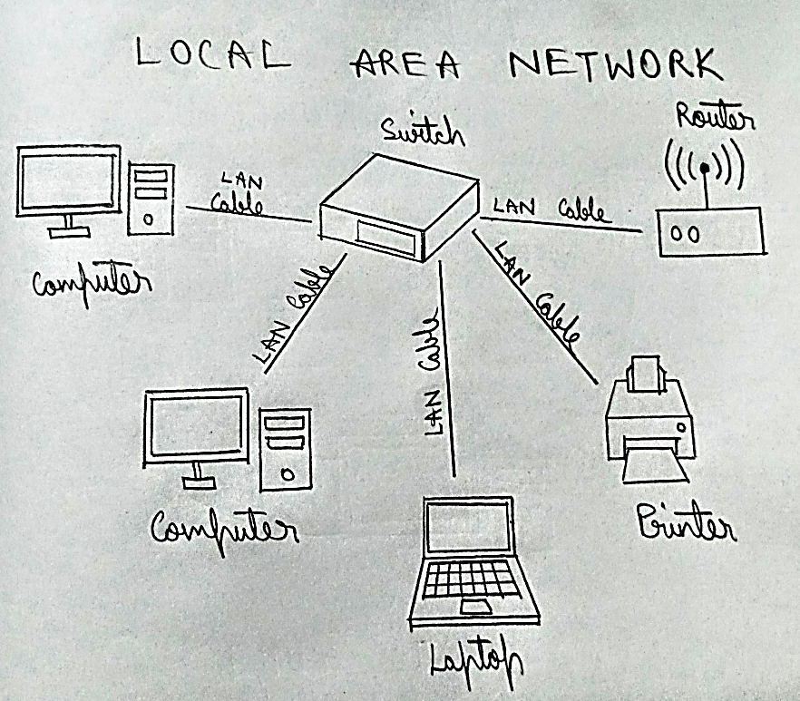

- A local area network (LAN) is a computer network covering a small geographic area, like a home, office, or group of buildings
- Most LANs connect to the Internet at a central point: a router. Home LANs often use a single router, while LANs in larger spaces may additionally use network switches for more efficient packet delivery.
- LANs almost always use Ethernet, Wi-Fi, or both in order to connect devices within the network. Ethernet is a protocol for physical network connections that requires the use of Ethernet cables. Wi-Fi is a protocol for connecting to a network via radio waves.
- A variety of devices can connect to LANs, including servers, desktop computers, laptops, printers, IoT devices, and even game consoles. In offices, LANs are often used to provide shared access to internal employees to connected printers or servers.

- METROPOLITAN AREA NETWORK:

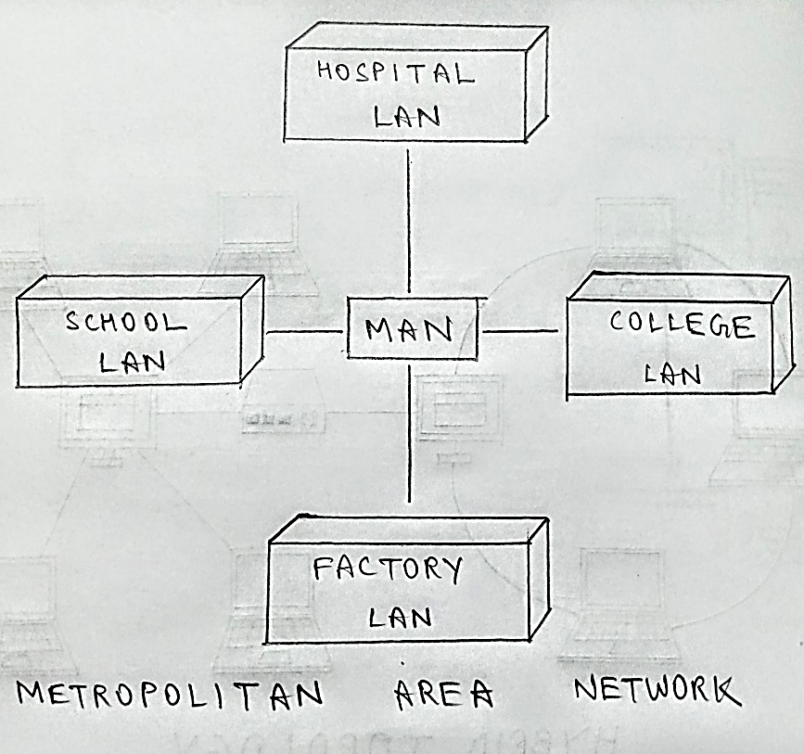

A metropolitan area network (MAN) is a network that interconnects users with computer resources in a geographic area or region larger than that covered by even a large local area network (LAN) but smaller than the area covered by a wide area network (WAN). The term is applied to the interconnection of networks in a city into a single larger network (which may then also offer efficient connection to a wide area network). It is also used to mean the interconnection of several local area networks by bridging them with backbone lines. The latter usage is also sometimes referred to as a campus network

- WIDE AREA NETWORK:

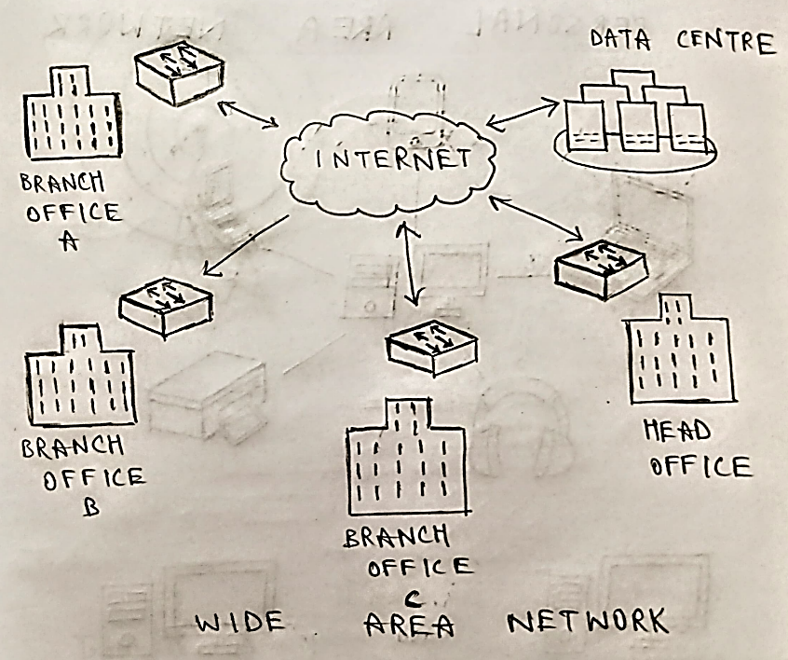

- Wide Area Network (WAN) is a computer network that covers a broad area (i.e., any network whose communications links cross metropolitan, regional, or national boundaries). Or, less formally, a network that uses routers and public communications links
- The largest and most well-known example of a WAN is the Internet.
- WANs are used to connect LANs and other types of networks together, so that users and computers in one location can communicate with users and computers in other locations.

- CAMPUS AREA NETWORK:

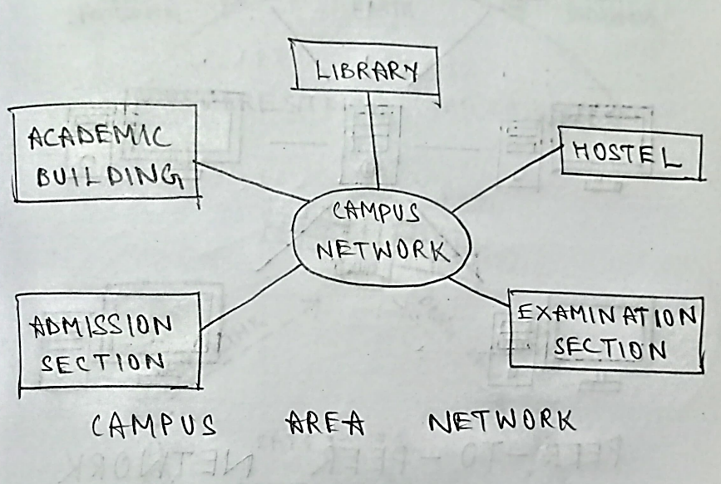
A campus area network (CAN) is a computer network that spans a limited geographic area. CANs interconnect multiple local area networks (LAN) within an educational or corporate campus. Most CANs connect to the public Internet.

- PERSONAL AREA NETWORK:

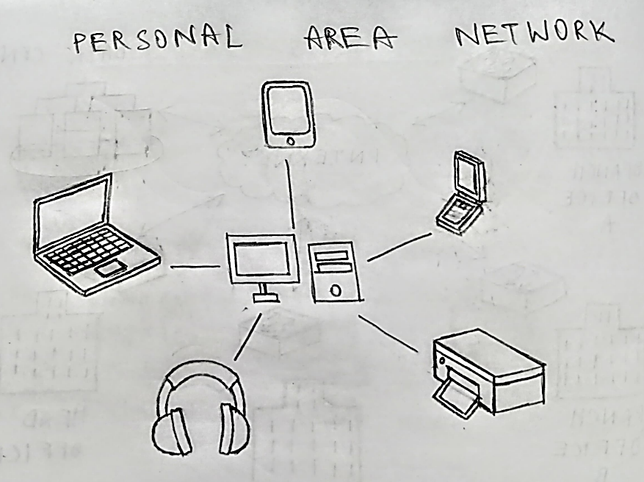

A personal area network (PAN) connects electronic devices within a user's immediate area. The size of a PAN ranges from a few centimetres to a few meters. One of the most common real-world examples of a PAN is the connection between a Bluetooth earpiece and a smart phone. PANs can also connect laptops, tablets, printers, keyboards, and other computerized devices.

- PEER-TO-PEER NETWORK:

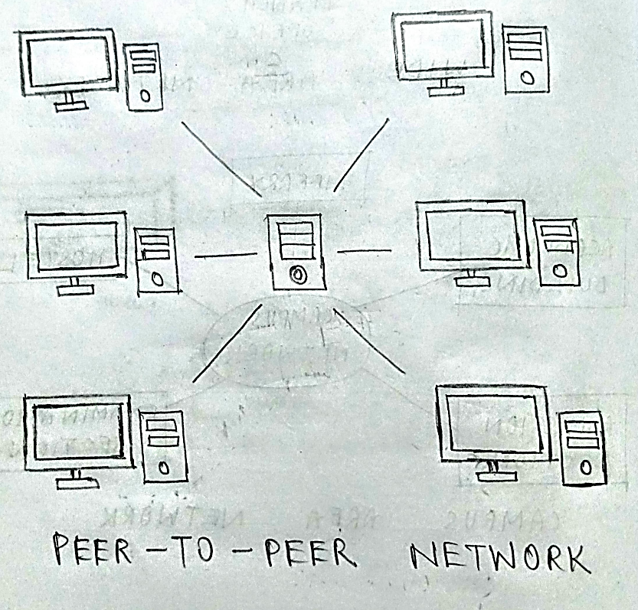

- A peer-to-peer network is a network where the computers act as both workstations and servers.
- Great for small, simple, and inexpensive networks.
- In a strict peer-to-peer networking setup, every computer is an equal, a peer in the network.
- Each machine can have resources that are shared with any other machine.
- There is no assigned role for any particular device, and each of the devices usually runs similar software. Any device can and will send requests to any other.

2a. Describe wireless transmission with neat sketch?
A)
- Transmission and reception are achieved by means of an antenna.
- Directional
- Transmitting antenna puts out focused beam.
- Transmitter and receiver must be aligned.
- Omnidirectional
- Signal spreads out in all directions.
- Can be received by many antennas.

- RADIO WAVES:

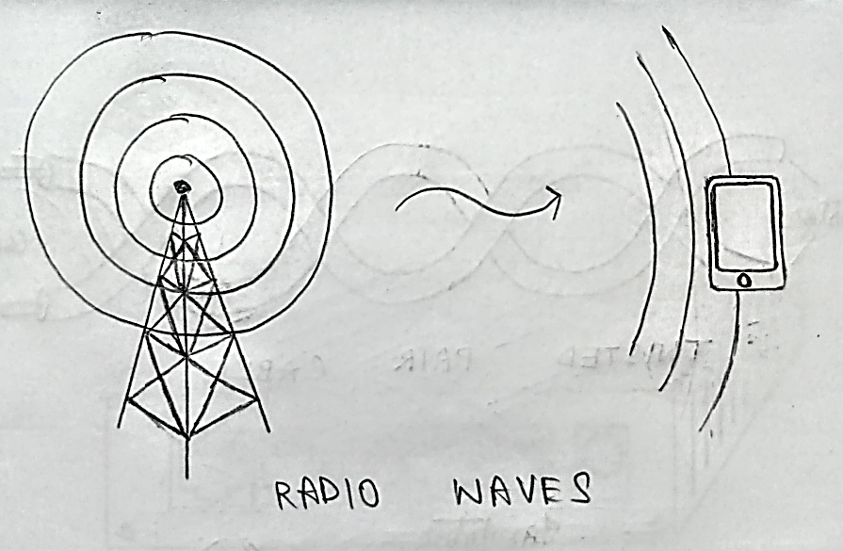

- Radio waves are used for multicast communications, such as radio and television.
- They can penetrate through walls.
- Highly regulated. Use Omni directional antennas
- Frequencies between 3 kHz and 1Ghz.
- Radio is omni-directional and microwave is directional
- Mobile telephony occupies several frequency bands just under 1 GHz.

- TERRESTRIAL MICROWAVES:

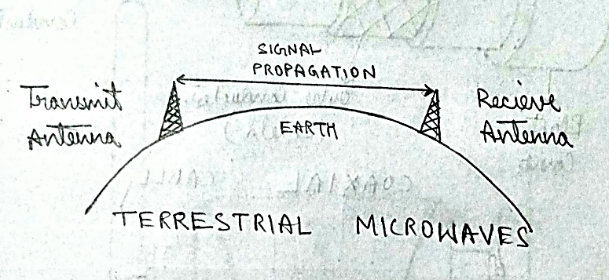
- Microwaves are used for unicast communication such as cellular telephones, satellite networks, and wireless LANs.
- Higher frequency microwaves cannot penetrate walls.
- Use directional antennas - point to point line of sight communications.
- It is a technology which transmits the focused beam of a radio signal from one ground-based microwave transmission antenna to another antenna.
- Microwaves are generally an electromagnetic wave which has the frequency in the range from 1GHz to 1000 GHz.
- These are unidirectional waves, whereas the sending and receiving antenna is to be aligned which means the antennas are narrowly focused.
- Here antennas are mounted on the towers to send a beam to another antenna which is present at km away.
- It works on the line-of-sight transmission, which means the antennas mounted on the towers are at the direct sight of each other.

- SATELLITE COMMUNICATION:

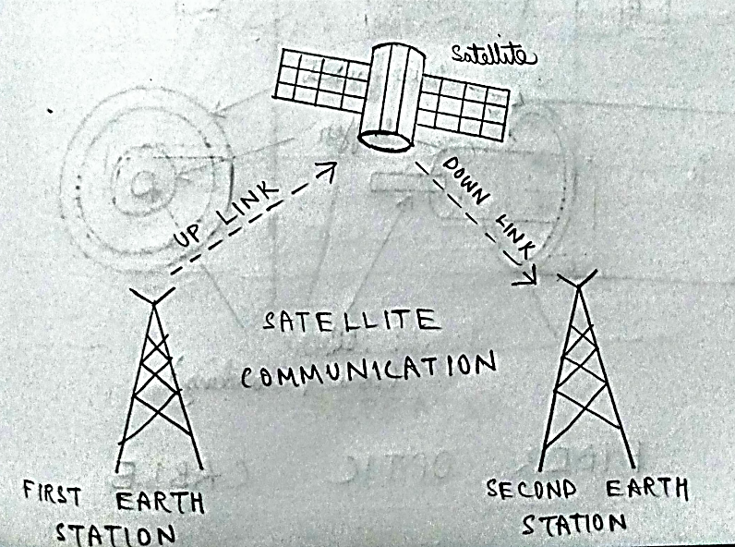

- In general terms, a satellite is a smaller object that revolves around a larger object in space. For example, moon is a natural satellite of earth.
- We know that Communication refers to the exchange (sharing) of information between two or more entities, through any medium or channel. In other words, it is nothing but sending, receiving and processing of information.
- satellite communication, in telecommunications, the use of artificial satellites to provide communication links between various points on Earth. Satellite communications play a vital role in the global telecommunications system.
- A typical satellite link involves the transmission or up linking of a signal from an Earth station to a satellite. The satellite then receives and amplifies the signal and retransmits it back to Earth, where it is received and reamplified by Earth stations and terminals.
- Satellite receivers on the ground include direct-to-home (DTH) satellite equipment, mobile reception equipment in aircraft, satellite telephones, and handheld devices.

2b. Explain guided transmission media in detail?
A) Guided media, which are those that provide a conduit from one device to another, include twisted-pair cable, coaxial cable, and fiber-optic cable.

- TWISTED PAIR CABLE:

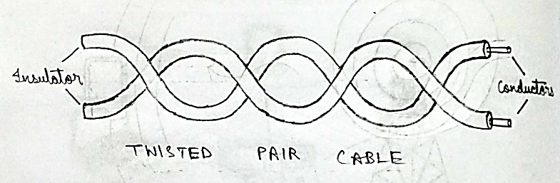

- Consists of two insulated copper wires arranged in a regular spiral pattern to minimize the electromagnetic interference between adjacent pairs.
- Often used at customer facilities and also over distances to carry voice as well as data communications.
- Low frequency transmission medium.
- Types of twisted-pair cable:
- STP (shielded twisted pair):
The pair is wrapped with metallic foil or braid to insulate the pair from electromagnetic interference.
- UTP (unshielded twisted pair):
Each wire is insulated with plastic wrap, but the pair is encased in an outer covering.
- Twisted Pair Advantages:
- Inexpensive and readily available
- Flexible and light weight
- Easy to work with and install
- Twisted Pair Disadvantages:
- Susceptibility to interference and noise
- Attenuation problem
- For analog, repeaters needed every 5-6km
- For digital, repeaters needed every 2-3km
- Relatively low bandwidth (3000Hz)

- COAXIAL CABLES (OR COAX):

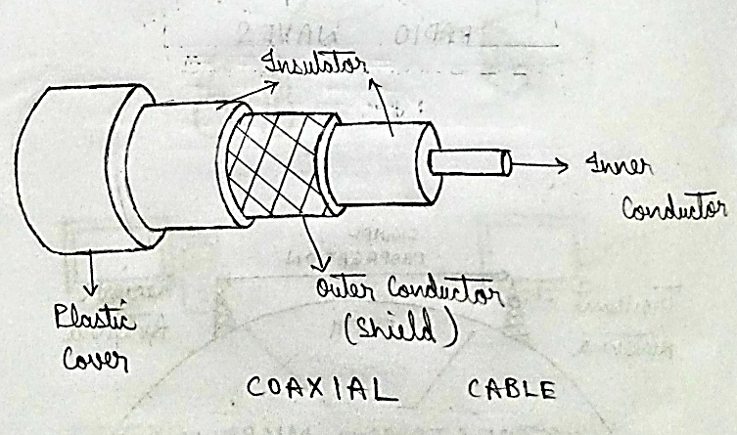

- Used for cable television, LANs, telephony
- Has an inner conductor surrounded by a braided mesh
- Both conductors share a common centre axial, hence the term “co-axial”
- Coax Advantages:
- Higher bandwidth
- 400 to 600Mhz
- up to 10,800 voice conversations
- Can be tapped easily (pros and cons)
- Much less susceptible to interference than twisted pair
- Coax Disadvantages:
- High attenuation rate makes it expensive over long distance
- Bulky
- FIBRE OPTIC CABLE:

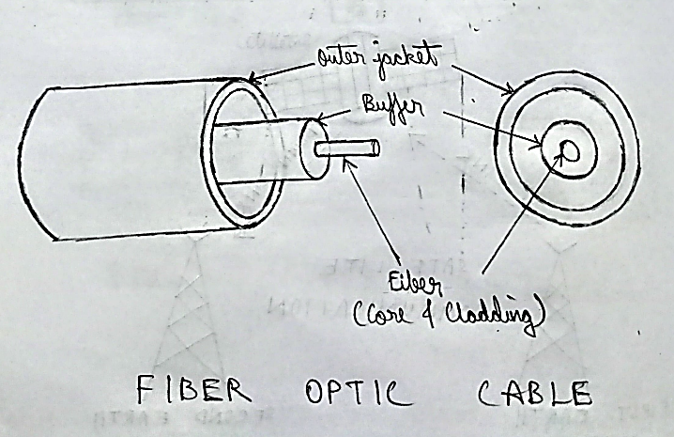

- Relatively new transmission medium used by telephone companies in place of long-distance trunk lines
- Also used by private companies in implementing local data communications networks
- Require a light source with injection laser diode (ILD) or light-emitting diodes (LED)
- Fiber Optic Types:
- multimode step-index fiber:
the reflective walls of the fiber move the light pulses to the receiver
- multimode graded-index fiber:
acts to refract the light toward the center of the fiber by variations in the density
- single mode fiber:
the light is guided down the center of an extremely narrow core

- Fiber Optic Advantages:
- greater capacity (bandwidth of up to 2 Gbps)
- smaller size and lighter weight
- lower attenuation
- immunity to environmental interference
- highly secure due to difficulty and lack of signal radiation
- Fiber Optic Disadvantages:
- Expensive over short distance
- Requires highly skilled installers
- Adding additional nodes is difficult

3. What are the five network performance metrics? Briefly explain
A)
- Network metrics are qualitative and quantitative ways to observe and determine network behaviour.
- Network performance monitoring tools are designed to deliver out-of-the-box visibility into network availability and performance metrics. They’re also designed to be fast, lightweight, and easy to use. To monitor network metrics, you can set alerts and get real-time notifications for outages and potential errors
- This way, you can make more informed decisions to minimize downtime and fix network failures. In addition, some of these tools allow you to monitor and track network bandwidth, network configurations

- DOWNLOADING:

- Downloading is the transmission of a file or data from one computer to another over a network, usually from a larger server to a user device. Download can refer to the general transfer of data or to transferring a specific file. It can also be called to download, DL or D/L.
- Downloading means your computer is receiving data from the Internet.
- Examples of downloading include opening a web page, receiving email, purchasing music files and watching online videos.

- UPLOADING:

- Uploading is the process of putting web pages, images and files onto a web server.
- Uploading (U/L) refers to the process of copying files from a smaller peripheral device to a large central system. This process may involve transferring data from a local computer to a remote computer (and usually large) system, or transferring data from a computer to a bulletin board system (BBS).
- Examples of uploading include sending email, posting photos on a social media site and using your webcam. Even clicking on a link on a web page sends a tiny data upload.

- BUFFERING:

- Buffering is the practice of pre-loading segments of data when streaming video content. Streaming — the continuous transmission of audio or video files from a server to a client — is the process that makes watching videos online possible. Buffering helps make streaming run more smoothly because videos can start playing before the entire video is loaded.
- Buffering is a core component of the streaming process. However, many viewers do not realize this and are only aware of the buffering process when it happens slowly or interrupts streaming. This is why viewers may use the word "buffering" to describe delays in content loading.
- Buffering can be compared to a grocery store's inventory and shelving process. Stores maintain inventory so they can easily restock shelves and avoid inconveniencing customers. Grocery store customers generally go about their shopping without thinking about the stocking process unless an item they want is unavailable. In the same way, video players pre-load video segments to avoid disrupting the viewing experience.

- SPEED BAUD RATE:

- Speed Baud Rate: Specify the rate at which bits are transmitted
- You configure Baud Rate as bits per second. The transferred bits include the start bit, the data bits, the parity bit (if used), and the stop bits. However, only the data bits are stored.
- The baud rate is the rate at which information is transferred in a communication channel. In the serial port context, "9600 baud" means that the serial port is capable of transferring a maximum of 9600 bits per second. If the information unit is one baud (one bit), then the bit rate and the baud rate are identical. If one baud is given as 10 bits, (for example, eight data bits plus two framing bits)
- The bit rate is still 9600 but the baud rate is 9600/10, or 960. You always configure Baud Rate as bits per second. Therefore, in the above example, set Baud Rate to 9600.

- BANDWIDTH:

- Network bandwidth is a measure of the data transfer rate or capacity of a given network. It’s a crucial network measurement for understanding the speed and quality of a network.
- Network bandwidth is commonly measured in bits per second (bps). In practice, organizations and internet service providers (ISPs) measure bandwidth in megabits per second (Mbps) or gigabits per second (Gbps).

4a. What is wireless LAN? Explain it briefly.
A)
- Wireless LAN (WLAN) stands for Wireless Local Area Network. It is a type of computer network that allows devices such as computers, laptops, smartphones, and other devices to connect and communicate with each other without the need for physical cables or wires. WLANs use radio waves to transmit and receive data over the air, allowing for flexible and convenient connectivity within a certain area, such as a home, office, or public space
- In a WLAN, a wireless access point (AP) acts as a central hub that connects wireless devices to a wired network, typically through a router or a switch. Wireless devices, such as laptops or smartphones, can connect to the wireless access point using Wi-Fi (Wireless Fidelity) technology, which is a set of wireless communication standards defined by the Institute of Electrical and Electronics Engineers (IEEE). Once connected, devices can communicate with each other and access network resources such as the internet or shared files.
- WLANs offer several advantages, including mobility, scalability, and ease of installation. Users can connect to the network without being tethered to a physical connection, allowing for greater freedom of movement. WLANs can be easily expanded or reconfigured to accommodate changes in network requirements or physical layout. Installation of WLANs typically involves minimal wiring compared to wired networks, making them relatively easy to set up and maintain.
- However, WLANs also have some limitations, such as potential interference from other wireless devices, limited range, and potential security concerns. Proper security measures, such as encryption and authentication, should be implemented to protect the privacy and integrity of data transmitted over a WLAN.
- Overall, WLANs provide wireless connectivity that enables devices to communicate and share data without the need for physical cables, offering flexibility and convenience in various settings.

4b. What is 5G technology and its applications? Explain it briefly
A)
5G technology refers to the fifth generation of mobile networks, which is the latest advancement in wireless communication technology. It offers significant improvements in terms of speed, capacity, latency, and connectivity compared to previous generations of mobile networks.
Some of the key features of 5G technology include:
- Increased Data Speeds: 5G networks are capable of delivering much higher data speeds compared to previous generations, with speeds potentially reaching up to 10 Gbps or higher. This allows for faster downloads, smoother streaming of high-definition content, and improved performance for bandwidth-intensive applications.
- Lower Latency: 5G networks have significantly lower latency compared to previous generations, which means that the time taken for data to travel between devices is greatly reduced. This enables real-time applications such as augmented reality (AR), virtual reality (VR), remote surgery, and autonomous vehicles to operate with minimal delay.
- Enhanced Connectivity: 5G technology supports a massive number of connected devices per unit area, known as device density. This enables the Internet of Things (IoT) and machine-to-machine (M2M) communication to thrive, allowing for seamless connectivity and communication between various devices and systems.
- Network Slicing: 5G introduces the concept of network slicing, which allows for the creation of multiple virtual networks within a single physical network. This enables tailored network configurations to meet the specific requirements of different applications, industries, and use cases.
- Applications in Various Industries: 5G has numerous applications across different industries, including but not limited to, telecommunications, healthcare, transportation, manufacturing, entertainment, smart cities, and agriculture. For example, it can enable remote telemedicine, enable autonomous vehicles to communicate with each other and with infrastructure for improved road safety, enable smart factories with efficient machine-to-machine communication, and power smart cities with enhanced connectivity for various services.

In summary, 5G technology offers significant improvements in terms of speed, capacity, latency, and connectivity, enabling a wide range of applications across various industries, and paving the way for new innovations and possibilities in the realm of wireless communication.

5a. Explain the characteristics of computer networks and list the advantages of computer networks?
A)
- A network can be defined as two or more computers connected together in such a way that they can share resources.
- The purpose of a network is to share resources.
- A resource may be:
- A file
- A folder
- A printer
- A disk drive
- Or just about anything else that exists on a computer
- A network is simply a collection of computers or other hardware devices that are connected together, either physically or logically, using special hardware and software.
- To allow them to exchange information and cooperate. Networking is the term that describes the processes involved in designing, implementing, upgrading, managing and otherwise working with networks and network technologies.
- Advantages of Networking:
- Connectivity and Communication
- Data Sharing
- Hardware Sharing
- Internet Access
- Internet Access Sharing
- Data Security and Management
- Performance Enhancement and Balancing
- Entertainment
- The Disadvantages (Costs) of Networking:
- Network Hardware, Software and Setup Costs
- Hardware and Software Management and Administration Costs
- Undesirable Sharing
- Illegal or Undesirable Behaviour
- Data Security Concerns

5b. Write short notes on a) HUB b) Repeater c) Switch d) Bridge e) Router f) Gateway g) Network Interface card h) RJ45
A)
(i) HUB:
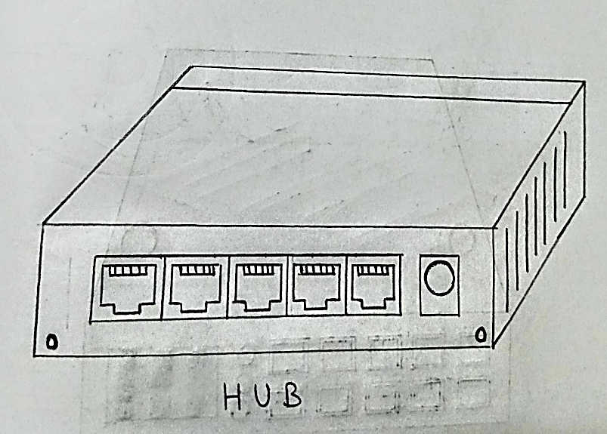
- It is a number of input lines that it joins electrically
- Frames arriving on any of the lines are sent out on all the others-listening problem
- All the lines coming into a hub must operate at the same speed
- Hubs differ from repeaters in the sense that they do not (usually) amplify the incoming signals and are designed for multiple input lines, but the differences are slight
- Hubs are physical layer components and have static addresses
- A network hub is a node that broadcasts data to every computer or Ethernet-based device connected to it. A hub is less sophisticated than a switch, the latter of which can isolate data transmissions to specific devices.
- Network hubs are best suited for small, simple local area network (LAN) environments.
- Hubs cannot provide routing capabilities or other advanced network services. Because they operate by forwarding packets across all ports indiscriminately, network hubs are sometimes referred to as "dumb switches."
(ii) REPEATER:
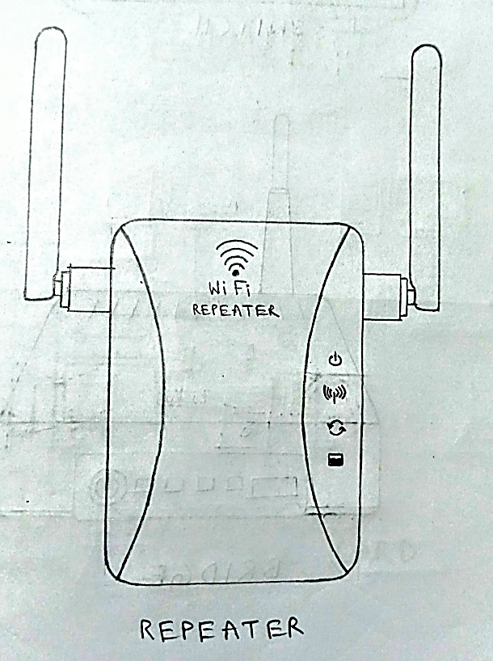

- Exist in the physical layer
- These are analog devices that work with signals on the cables to which they are connected
- A signal appearing on one cable is cleaned up, amplified, and put on another cable
- Repeaters do not understand the symbols that encode bits as volts
- Classic Ethernet, for example, was designed to allow four repeaters that would boost the signal to external distances ranging from 500m to 2500m

(iii) SWITCH:

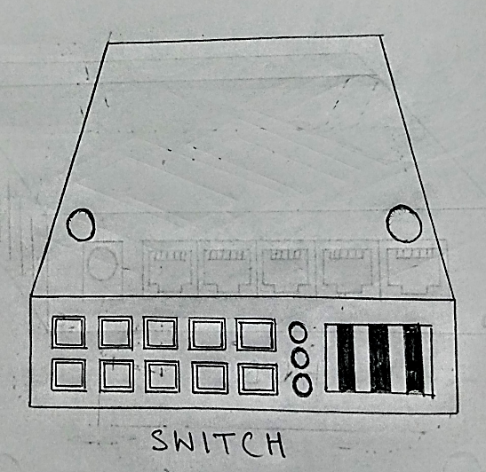

- Switches are active devices, has many ports and at data link layer
- They act as connection between two LANs
- Use packet switching to send, receive or forward data packets or frames
- Use MAC address to send packets to selected destination ports
- It supports unicast (one-to-one), multicast (one-to-many) and broadcast (one-to-all) communications with full duplex channel
- Prevents data collision
- Reduces network congestion
- Increases network performance

(iv) BRIDGE:
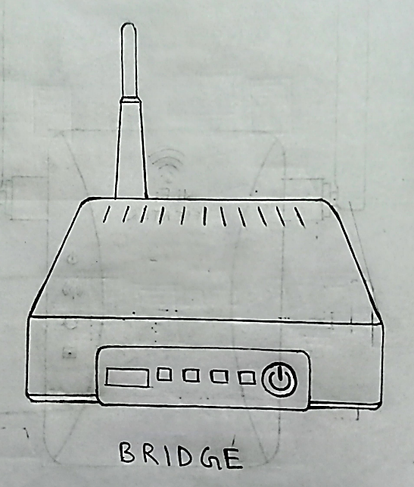

- Connects two LANs and forwards or filters data packets between them.
- Creates an extended network in which any two workstations on the linked LANs can share data.
- Transparent to protocols and to higher level devices like routers.
- Forward data depending on the Hardware (MAC) address, not the Network address (IP).
- Resides on Layer 2 of the OSI model.
(v) ROUTER:
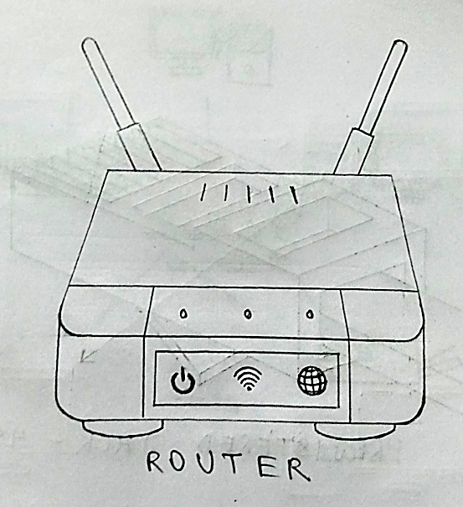

- A device that connects any number of LANs.
- Uses standardized protocols to move packets efficiently to their destination
- More sophisticated than bridges, connecting networks of different types (for example, star and token ring) Forwards data depending on the Network address (IP), not the Hardware (MAC) address
- Routers are the only one of these four devices that will allow you to share a single IP address among multiple network clients.
- Resides on Layer 3 of the OSI model.

(vi) GATEWAY:

- Connects networks with different protocols like TCP/IP network and IPX/SPX networks.
- Routers and Gateways often refer to the same device.
- It can copy the packets from one connection to another, reformatting them as needed
- Transport Gateways present in the transport layer connect two computers that use different connection-oriented transport protocols
- Finally, application gateways understand the format and contents of the data and can translate them

(vii) NETWORK INTERFACE CARDS(NICs):

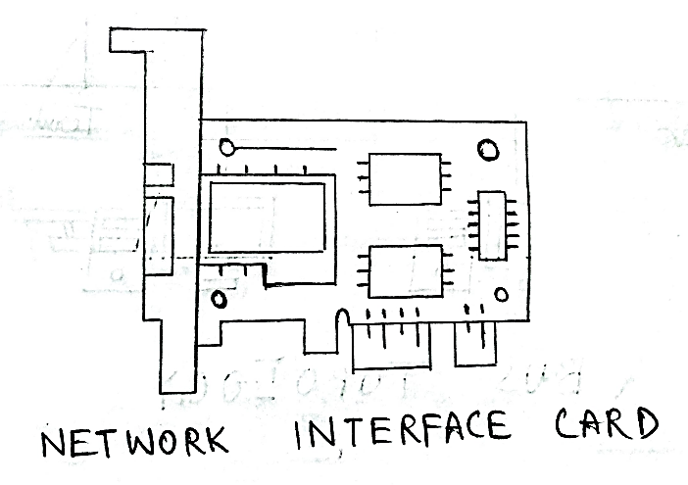

- Puts the data into packets and transmits packet onto the network.
- May be wired or wireless.
- It is a component of both physical layer and data link layer

(viii) RJ45(REJISTERED JACK-45):
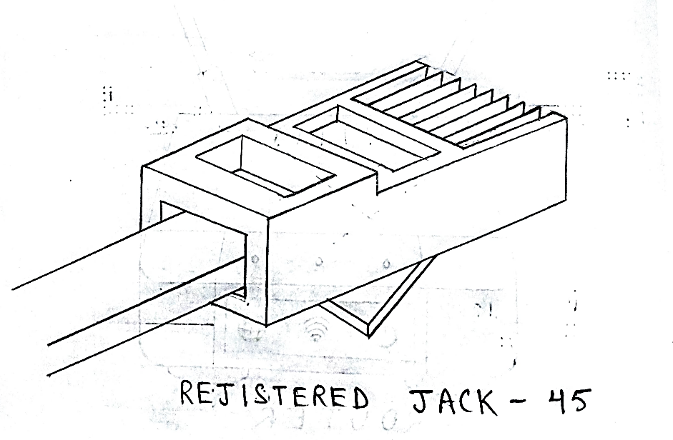

- A registered jack (RJ) is a standardized physical network interface for connecting telecommunications or data equipment. The physical connectors that registered jacks use are mainly of the modular connector and 50-pin miniature ribbon connector types. The most common twisted-pair connector is an 8-position, 8-contact (8P8C) modular plug and jack commonly referred to as an RJ45 connector.
- RJ45 is a type of connector commonly used for Ethernet networking. It looks similar to a telephone jack, but is slightly wider. Since Ethernet cables have an RJ45 connector on each end, Ethernet cables are sometimes also called RJ45 cables. The "RJ" in RJ45 stands for "registered jack," since it is a standardized networking interface. The "45 " simply refers to the number of the interface standard. Each RJ45 connector has eight pins, which means an RJ45 cable contains eight separate wires. If you look closely at the end of an Ethernet cable, you can actually see the eight wires, which are each a different colour. Four of them are solid colours, while the other four are striped.

6. Discuss various types of networks topologies in computer networks?
A)
- A topology is a way of “laying out” the network. Topologies can be either physical or logical.
- Physical topologies describe how the cables are run.
- Logical topologies describe how the network messages travel
(i) BUS TOPOLGY:
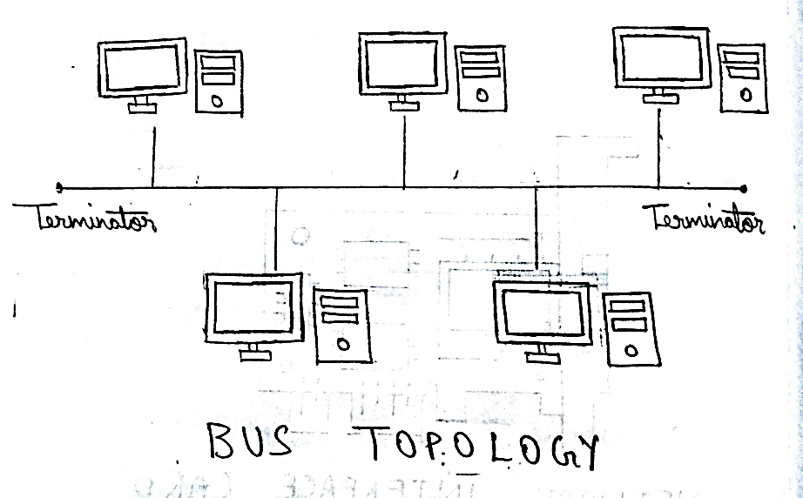

- A bus is the simplest physical topology. It consists of a single cable that runs to every workstation
- This topology uses the least amount of cabling, but also covers the shortest amount of distance.
- It is difficult to add a workstation
- Have to completely reroute the cable and possibly run two additional lengths of it.
- If any one of the cables breaks, the entire network is disrupted. Therefore, it is very expensive to maintain.

(ii) STAR TOPOLOGY:
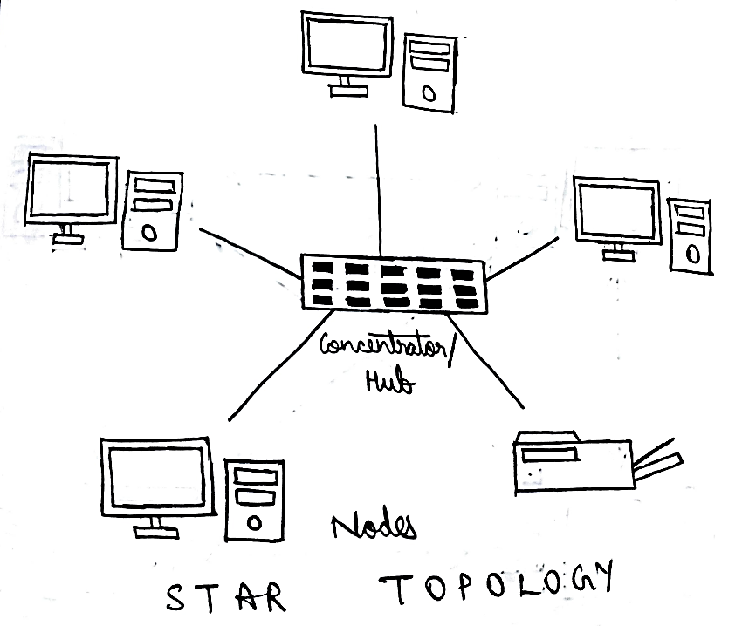

- A physical star topology branches each network device off a central device called a hub, making it very easy to add a new workstation.
- Also, if any workstation goes down it does not affect the entire network. (But, as you might expect, if the central device goes down, the entire network goes down.)
- Some types of Ethernets and ARCNet use a physical star topology.
- Star topologies are easy to install. A cable is run from each workstation to the hub. The hub is placed in a central location in the office.
- Star topologies are more expensive to install than bus networks, because there are several more cables that need to be installed, plus the cost of the hubs that are needed.

(iii) RING TOPOLOGY:
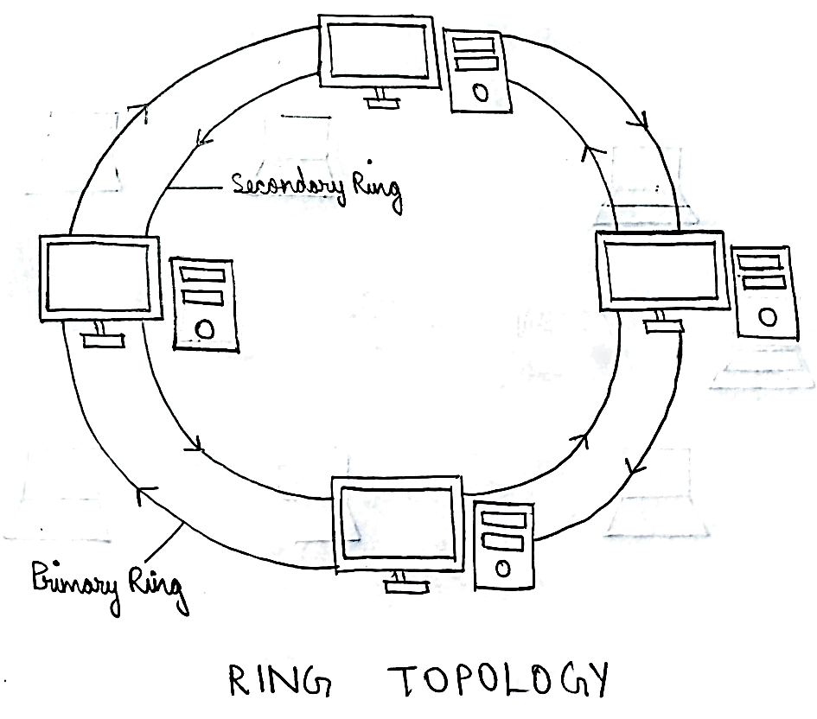
- Each computer connects to two other computers, joining them in a circle creating a unidirectional path where messages move workstation to workstation.
- Each entity participating in the ring reads a message, then regenerates it and hands it to its neighbour on a different network cable.
- The ring makes it difficult to add new computers.
- Unlike a star topology network, the ring topology network will go down if one entity is removed from the ring.
- Physical ring topology systems don’t exist much anymore, mainly because the hardware involved was fairly expensive and the fault tolerance was very low.

(iv) MESH TOPOLOGY:
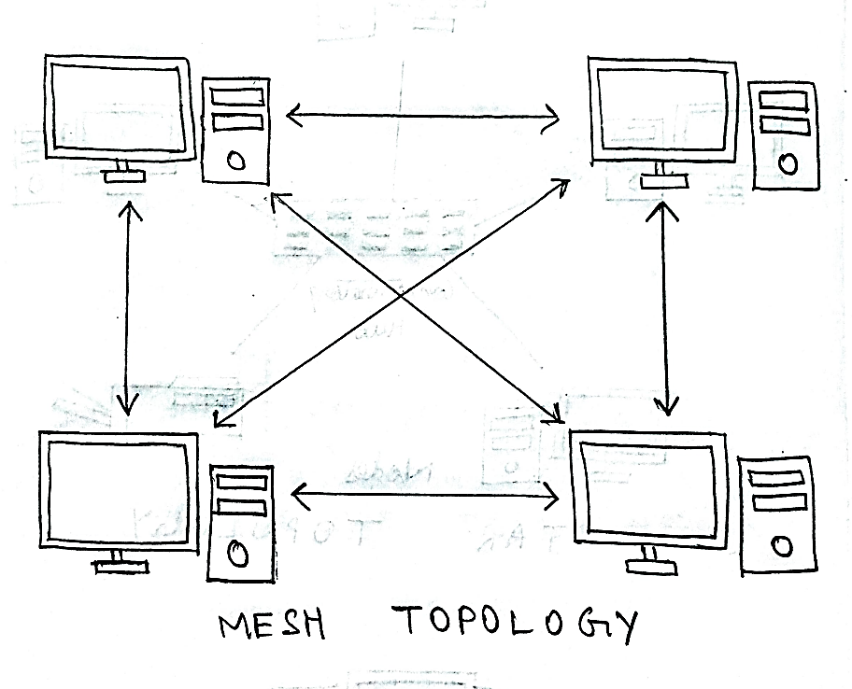

- The mesh topology is the simplest logical topology in terms of data flow, but it is the most complex in terms of physical design.
- In this physical topology, each device is connected to every other device
- This topology is rarely found in LANs, mainly because of the complexity of the cabling.
- If there are x computers, there will be (x × (x–1)) ÷ 2 cables in the network. For example, if you have five computers in a mesh network, it will use 5 × (5 – 1) ÷ 2, which equals 10 cables. This complexity is compounded when you add another workstation.

(v) HYBRID TOPOLOGY:
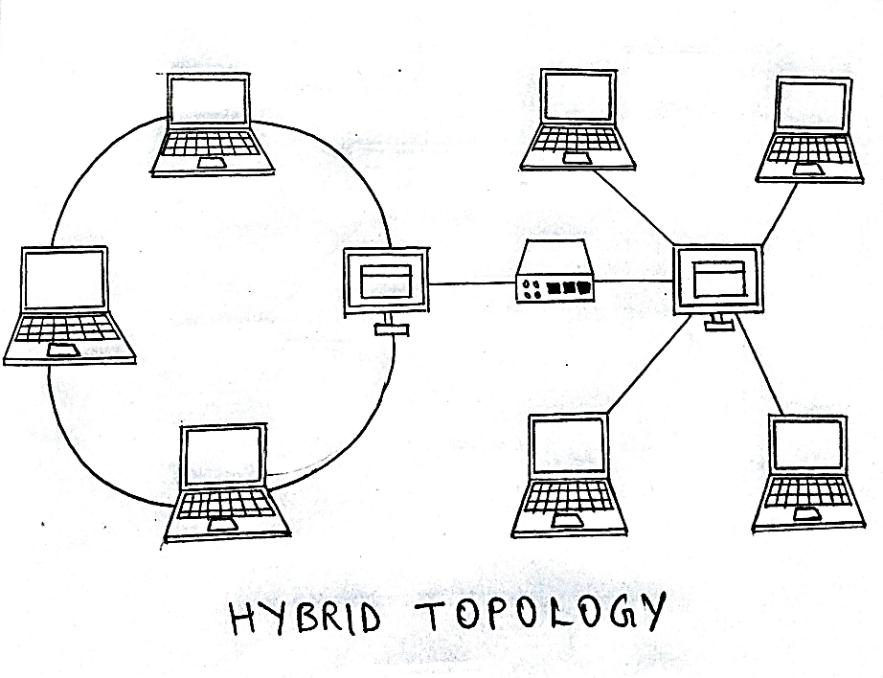

- A hybrid topology is a type of network topology that uses two or more differing network topologies.
- These topologies can include a mix of bus topology, mesh topology, ring topology, star topology, and tree topology
- Each individual topology uses their respective protocol.

